**Case study of VPC and Peering**

**Problem Statement:**

**You work for XYZ Corporation and based on the expansion requirements of your**

**corporation you have been asked to create and set up a distinct Amazon VPC for**

**the production and development team. You are expected to perform the following**

**tasks for the respective VPCs.**

**Production Network:**

**1. Design and build a 4-tier architecture.**

**2. Create 5 subnets out of which 4 should be private named app1, app2,**

**dbcache and db and one should be public, named web.**

**3. Launch instances in all subnets and name them as per the subnet that**

**they have been launched in.**

**4. Allow dbcache instance and app1 subnet to send internet requests.**

**5. Manage security groups and NACLs.**

**Development Network:**

**1. Design and build 2-tier architecture with two subnets named web and db**

**and launch instances in both subnets and name them as per the subnet**

**names.**

**2. Make sure only the web subnet can send internet requests.**

**3. Create peering connection between production network and development**

**network.**

**4. Setup connection between db subnets of both production network and**

**development network respectively**

1. **Design and build a 4-tier architecture.**

**2. Create 5 subnets out of which 4 should be private named app1, app2, dbcache and db and one should be public, named web.**

**3. Launch instances in all subnets and name them as per the subnet that they have been launched in.**

**4. Allow dbcache instance and app1 subnet to send internet requests.**

a. Created the vpc

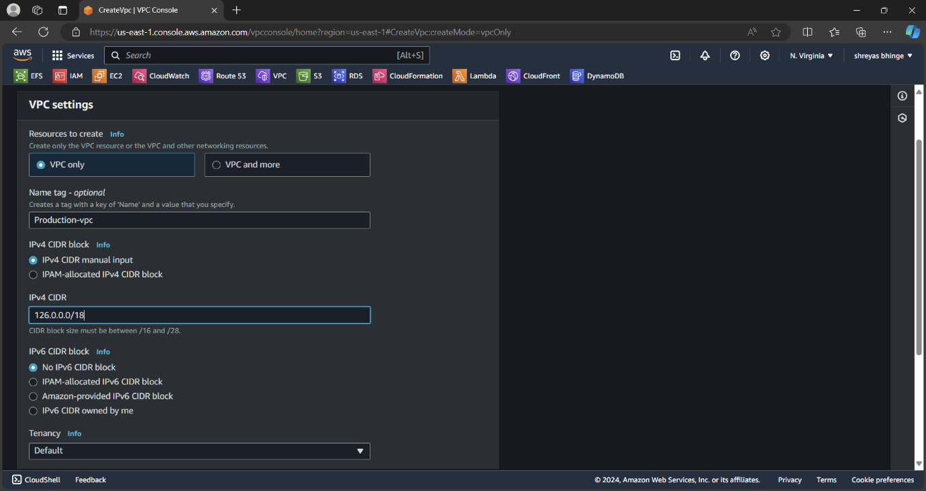

b. Created the five subnet

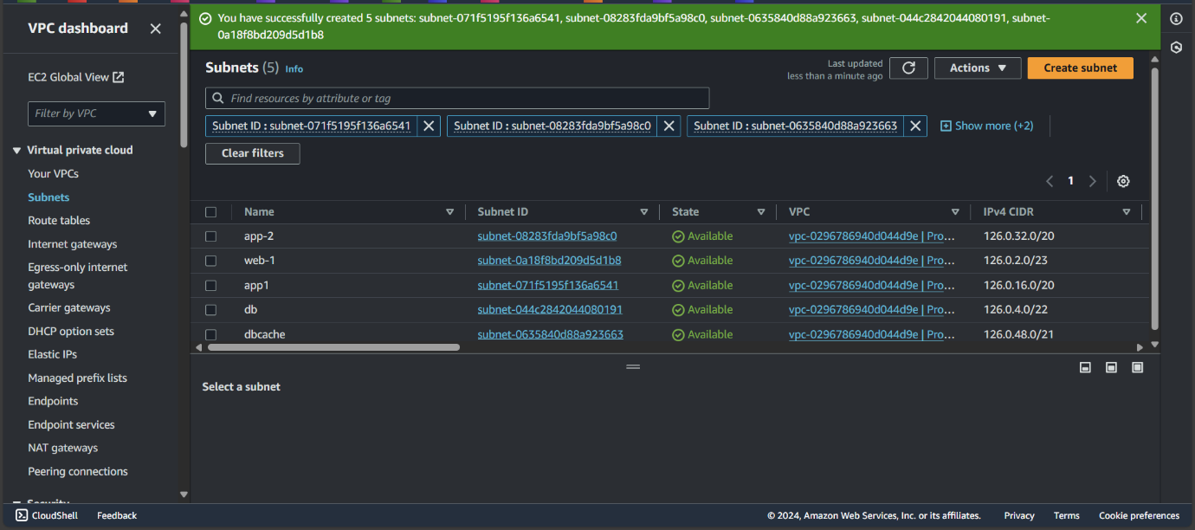

c. Web subnet should have internet connection created route table and internet gateway

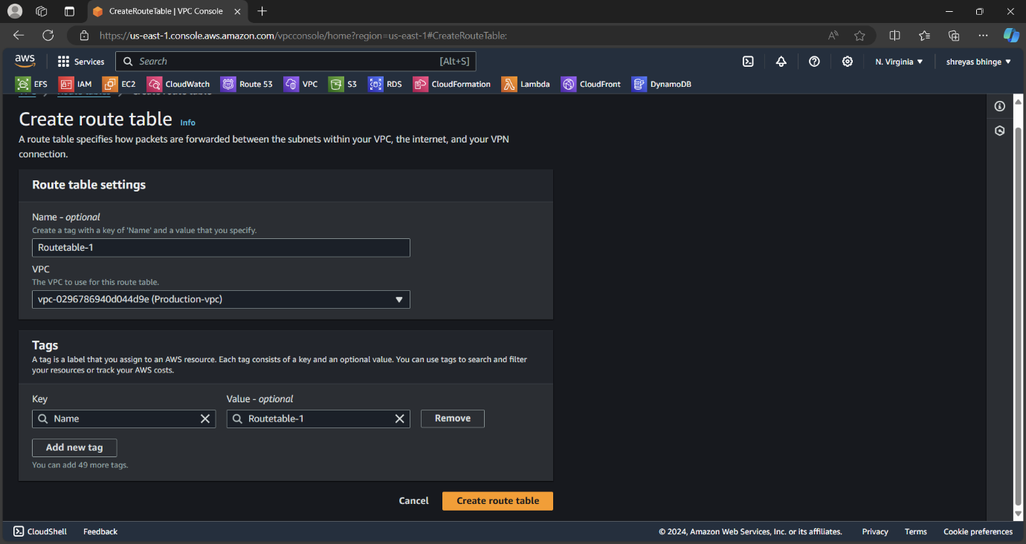

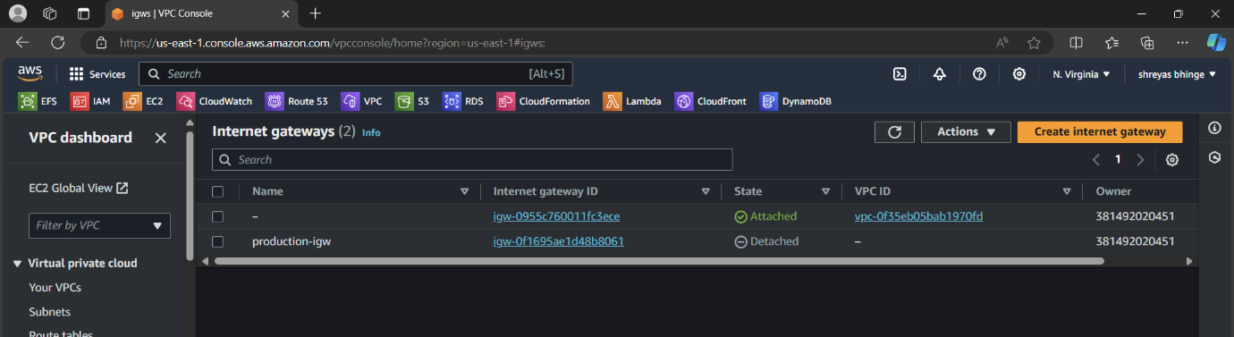

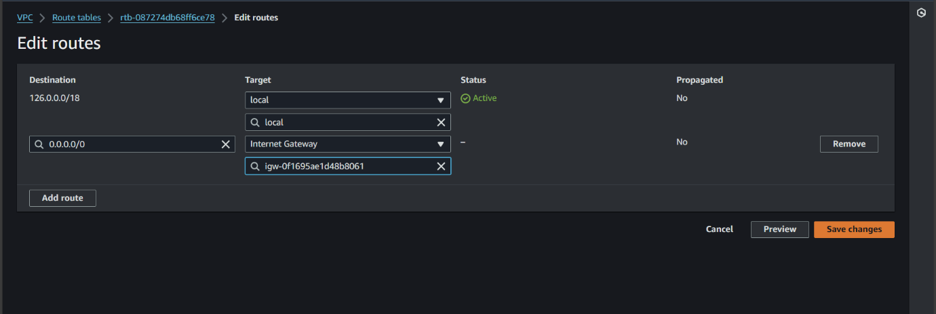

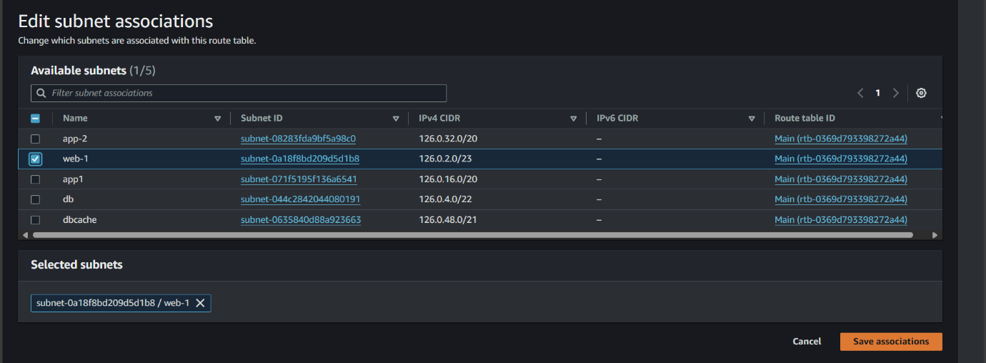

d. Created 5 instance in each subnet

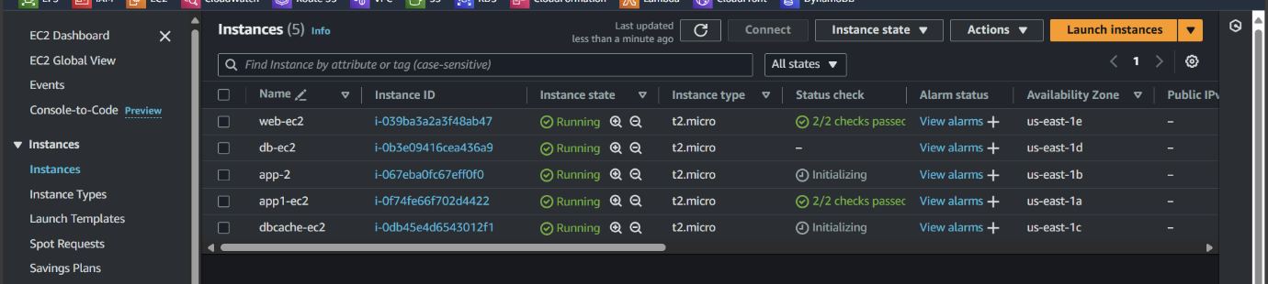

e. Connected web instance and checked internet connection

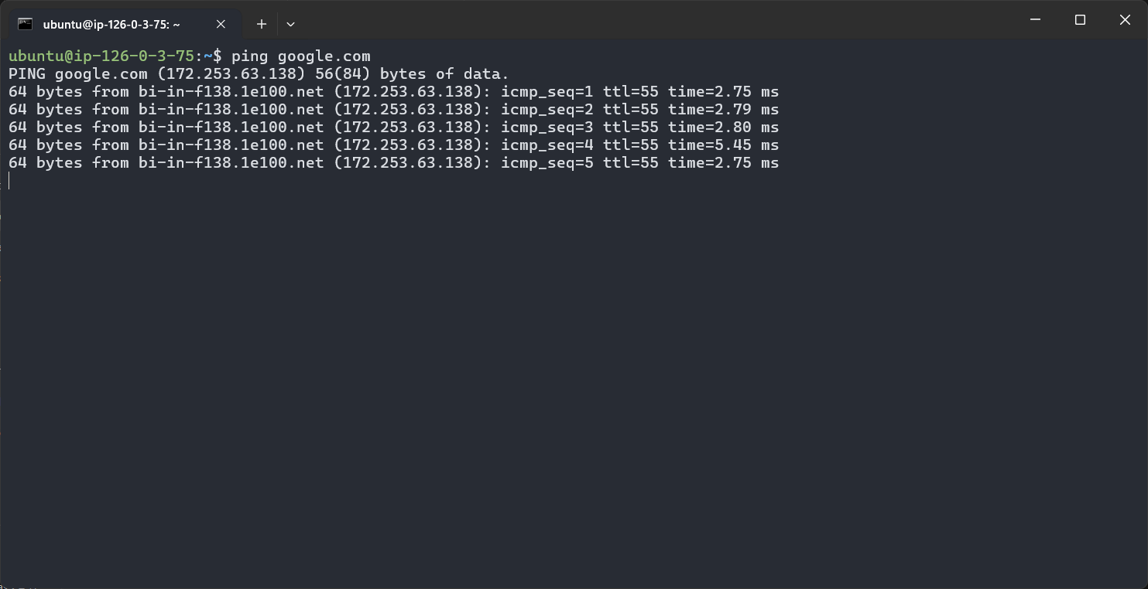

f. Created Routetable-2 for connecting dbcache and app1 instances by NAT gateway

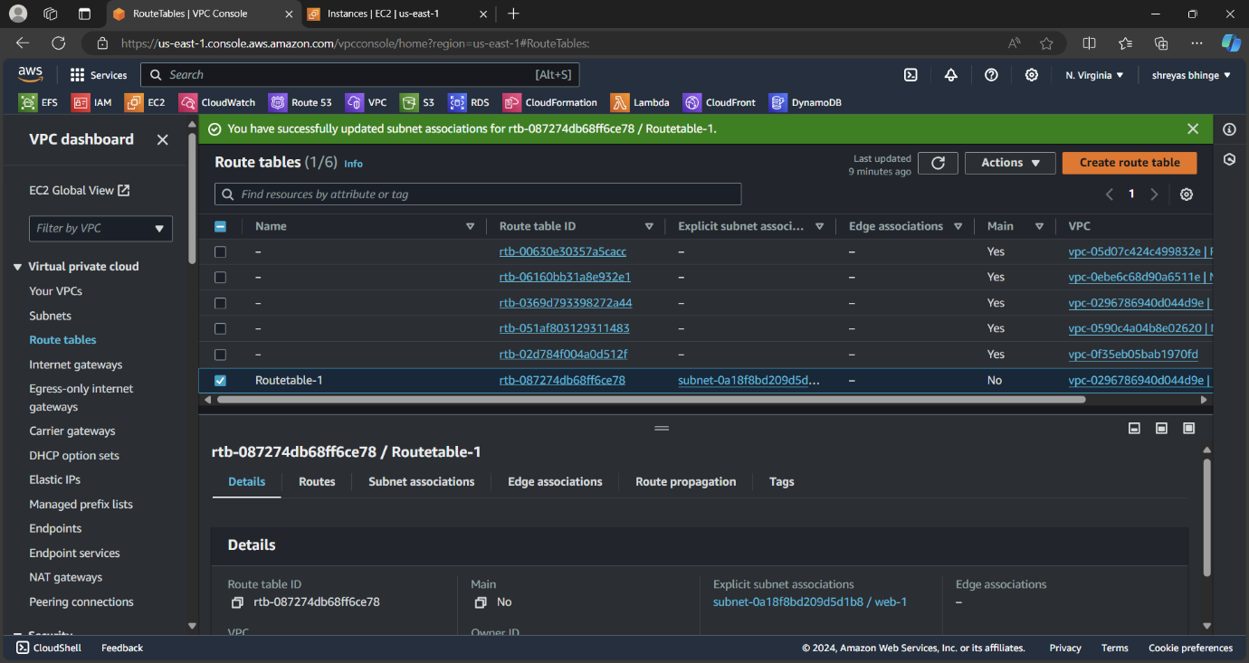

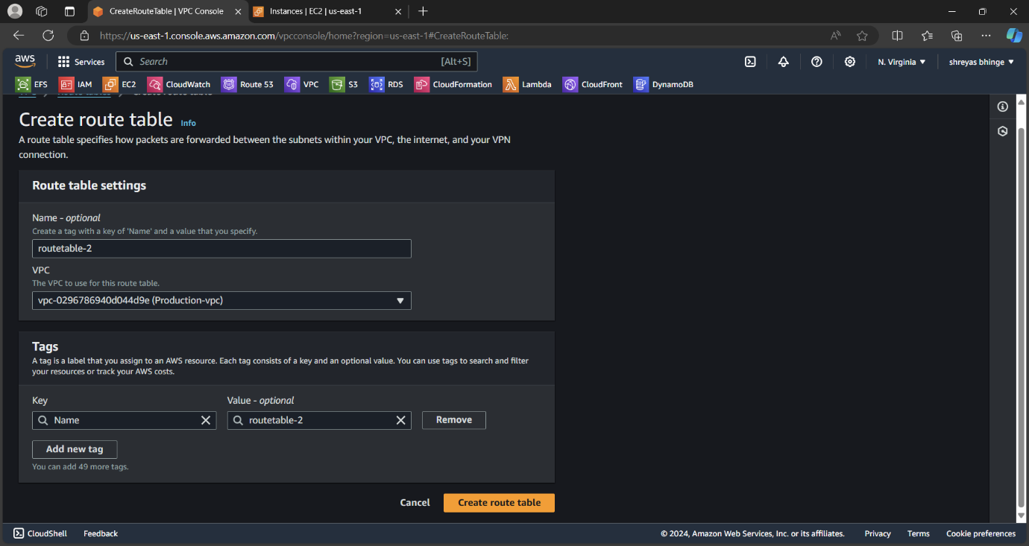

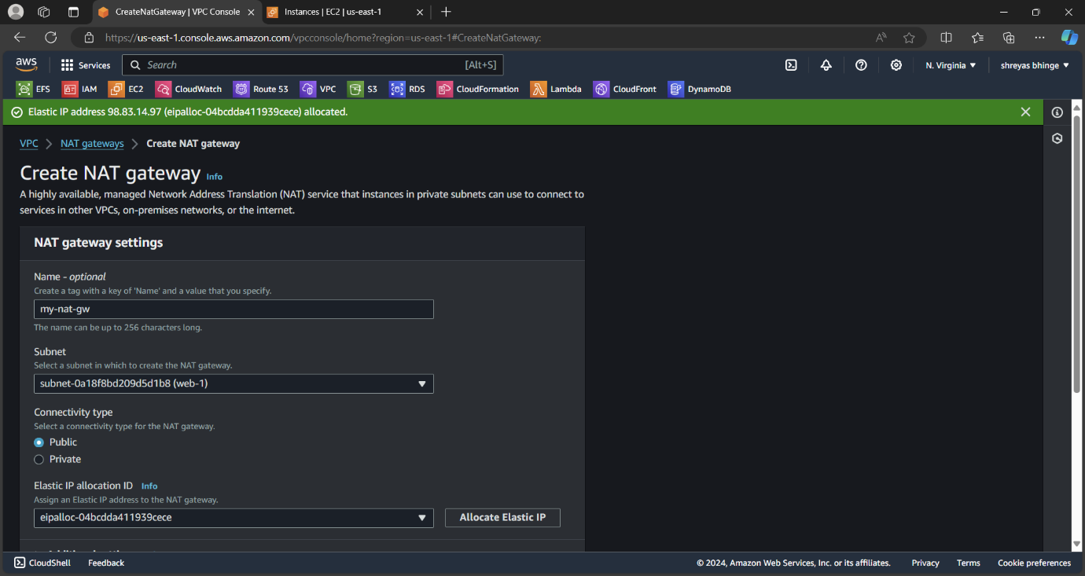

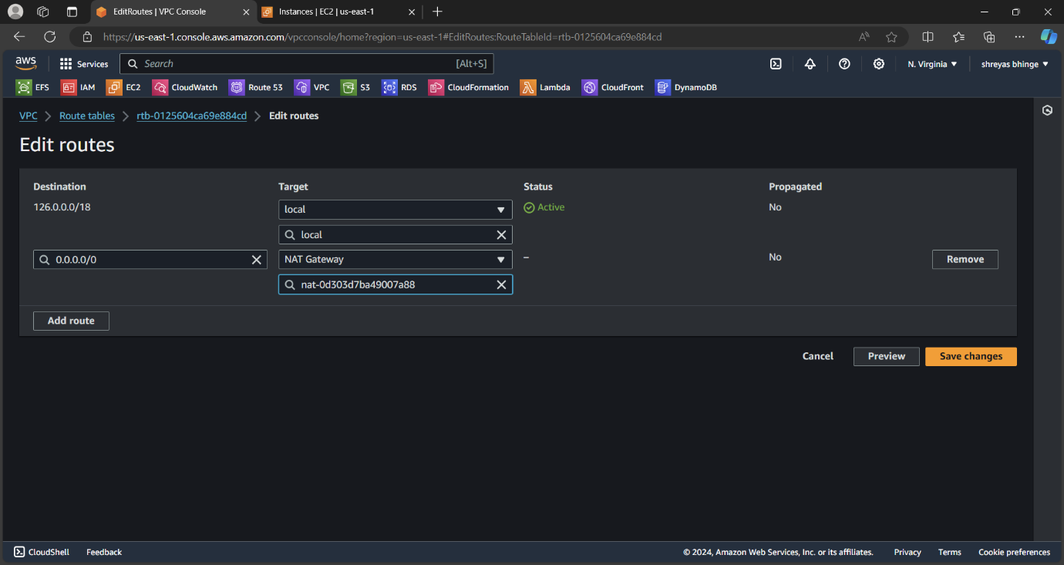

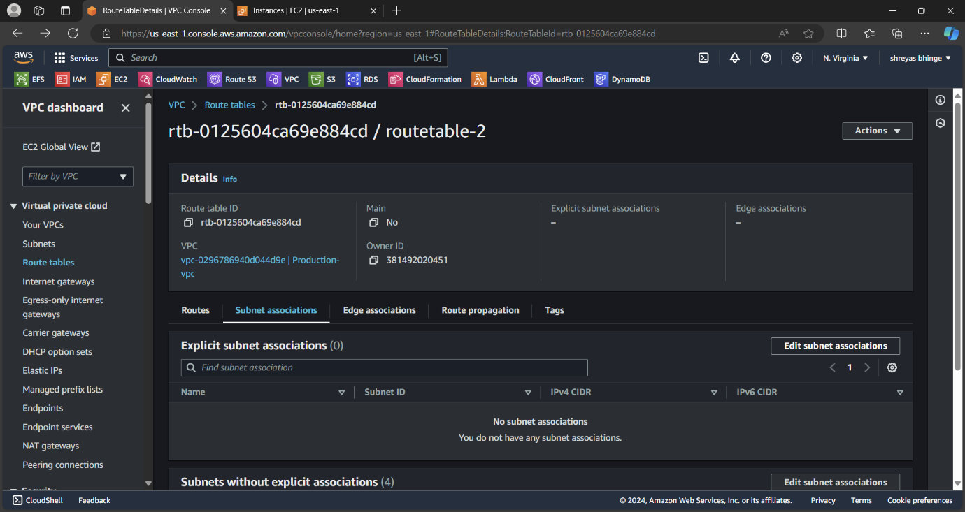

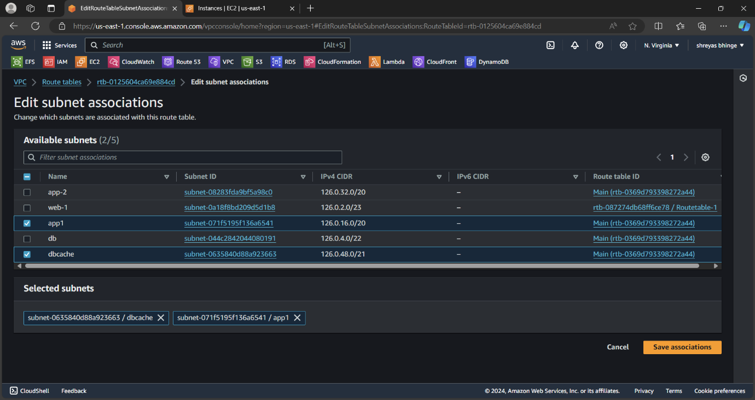

g. Connect the web instance which has internet access

use commands:

1. Nano Demo-1.pem
2. Add private key and save
3. Chmod 400 Demo-1.pem
4. Ssh -i Demo-1.pem ubuntu@Private ip of dbcahe

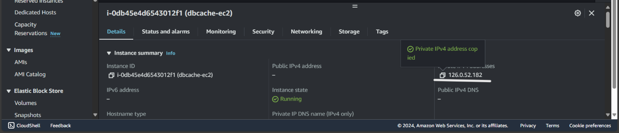

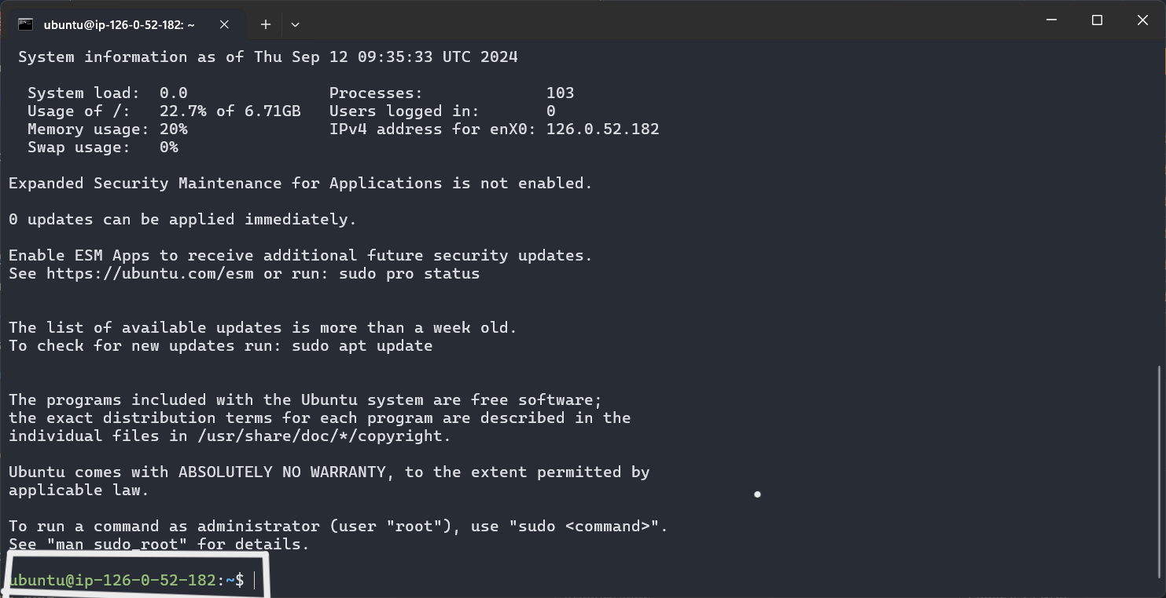

Checked internet connection

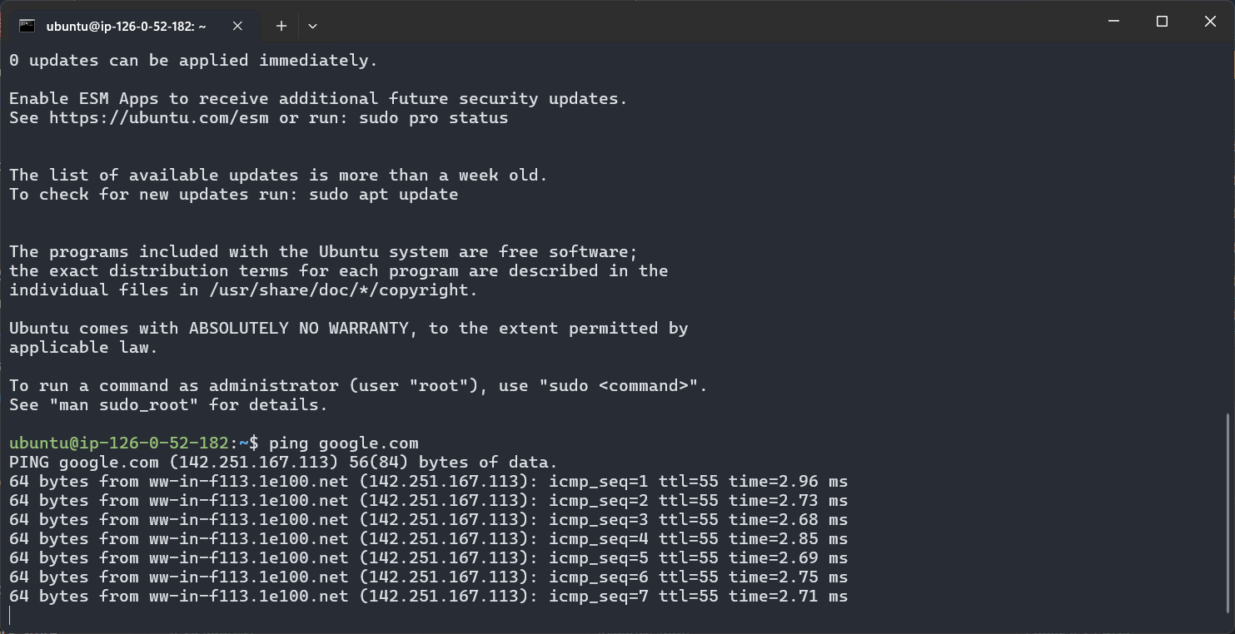

h. Also connected app1 same as above

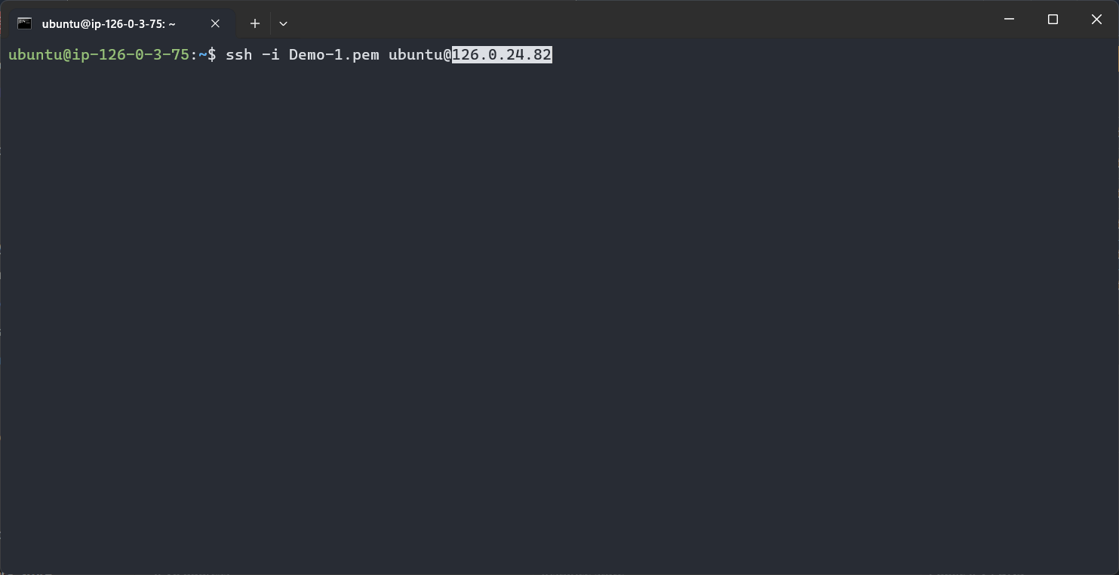

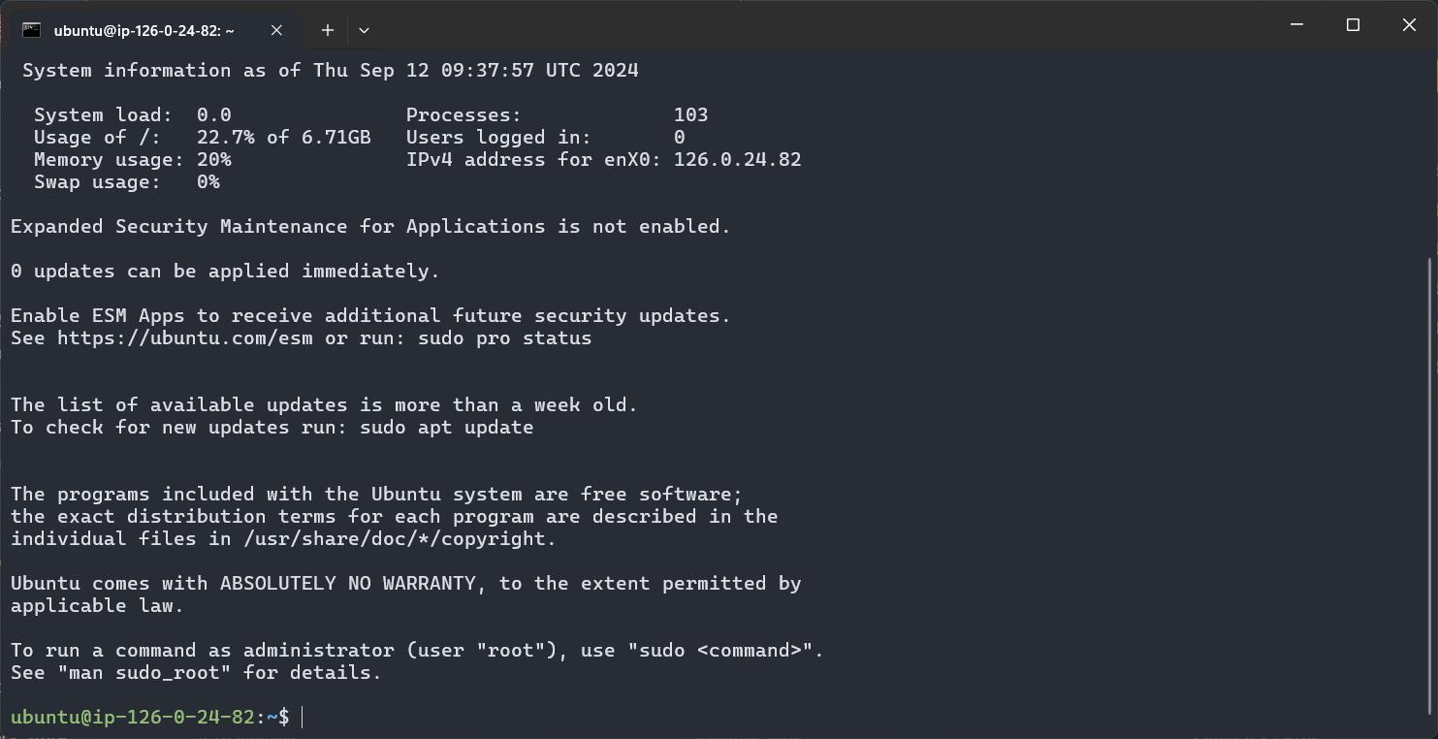

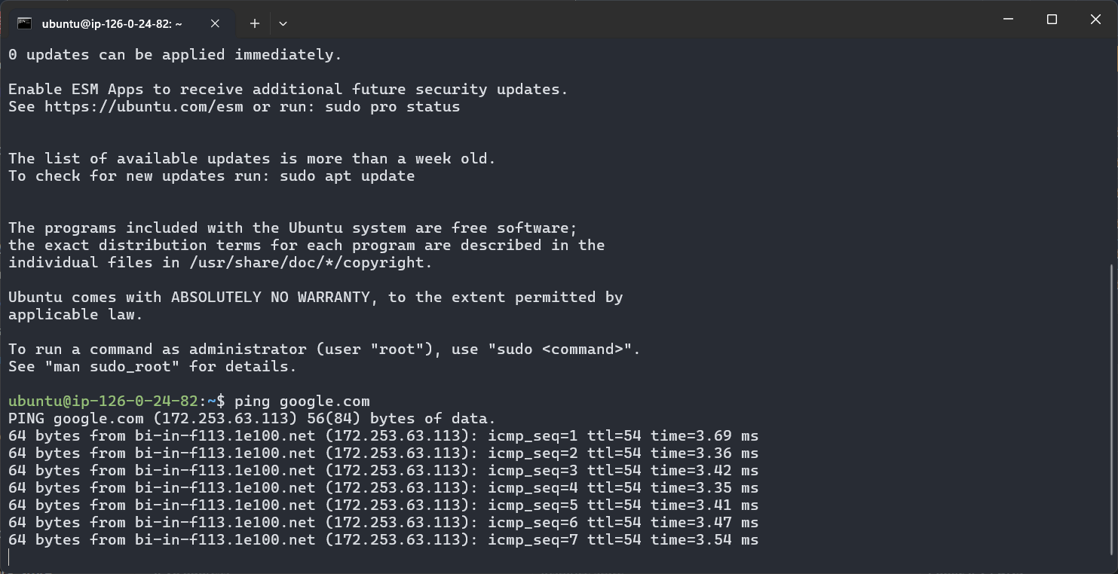

**Development Network:**

**1. Design and build 2-tier architecture with two subnets named web and db**

**and launch instances in both subnets and name them as per the subnet**

**names.**

**2. Make sure only the web subnet can send internet requests.**

**3. Create peering connection between production network and development**

**network.**

**4. Setup connection between db subnets of both production network and**

**development network respectively**

1. Created VPC

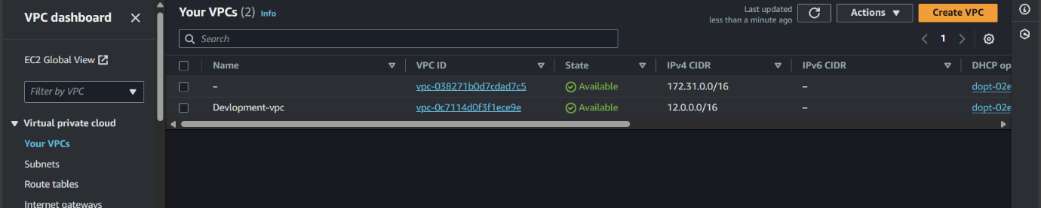

1. Two subnet web-2 and db2

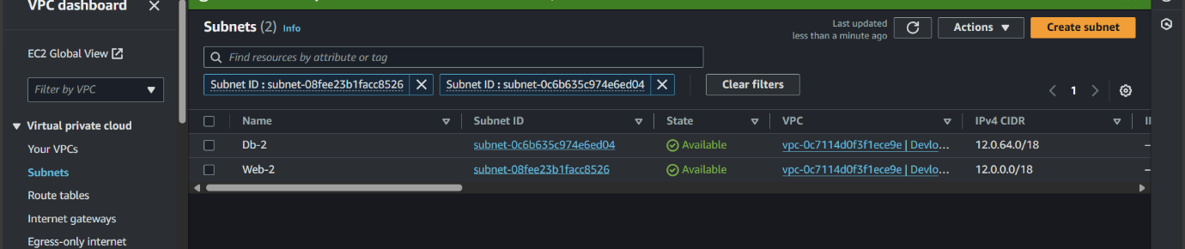

1. Created routetable and internet gateway

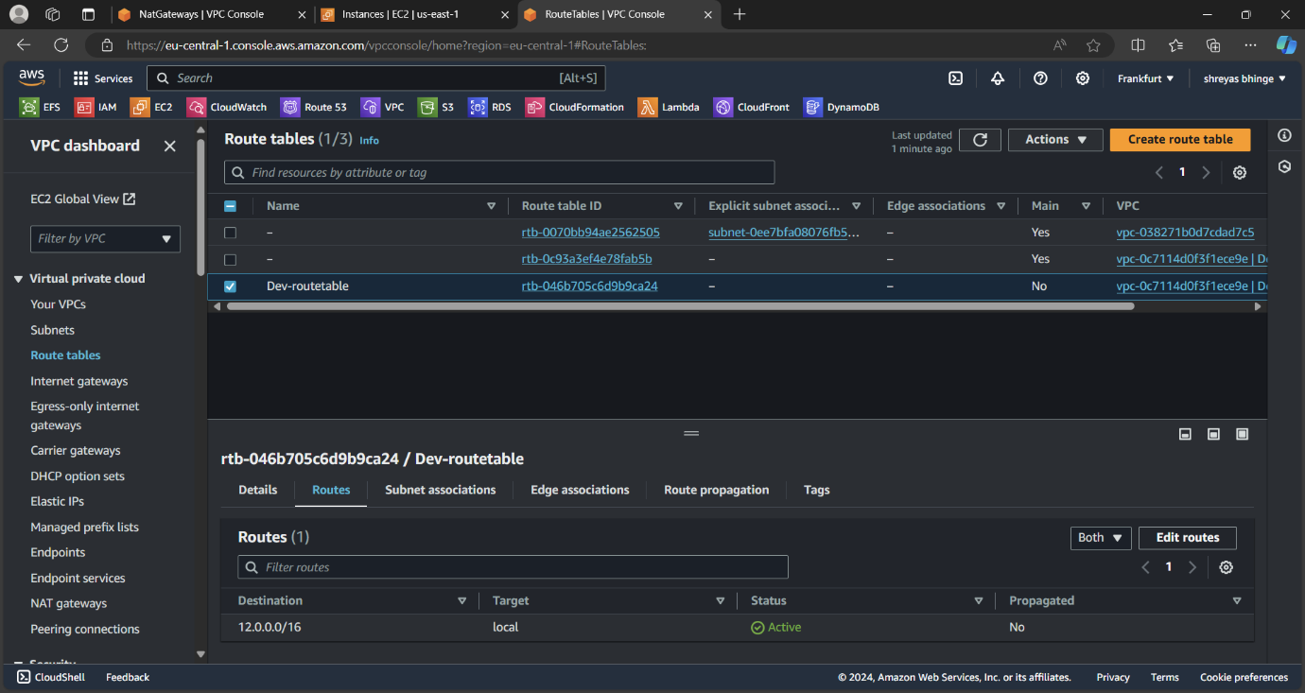

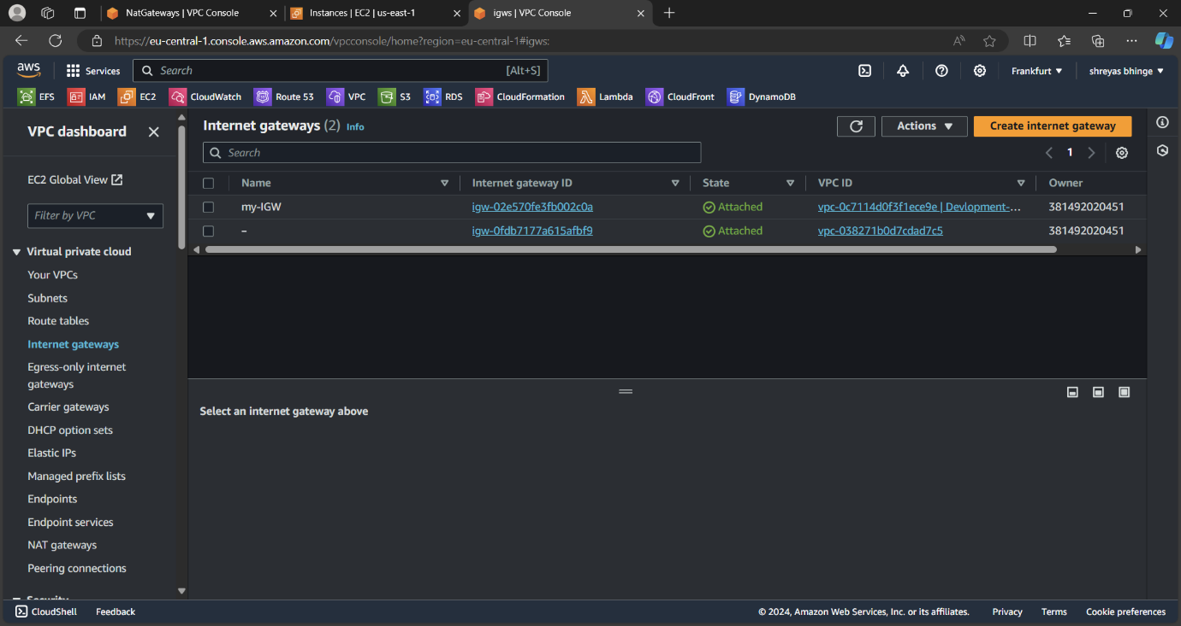

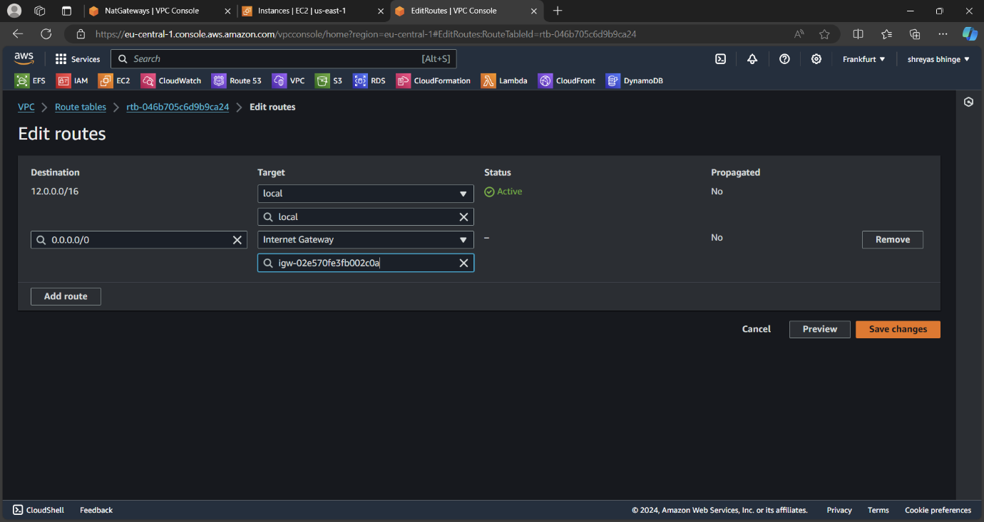

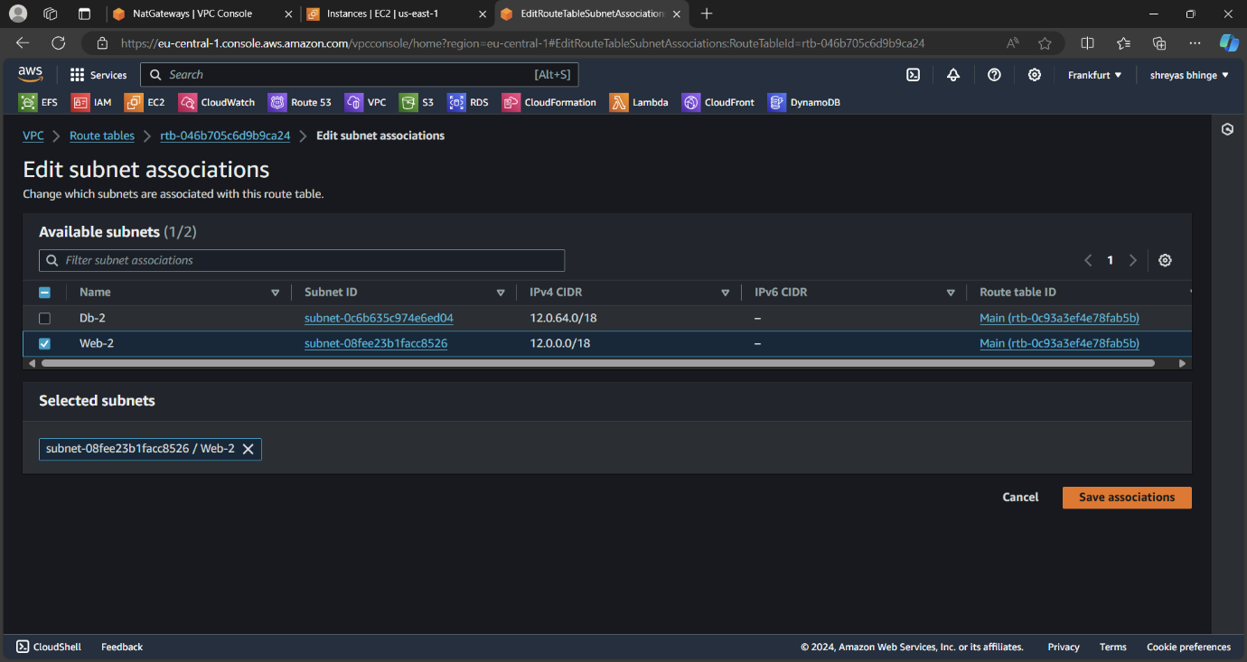

1. Create two instance in each subnet and name after the subnet

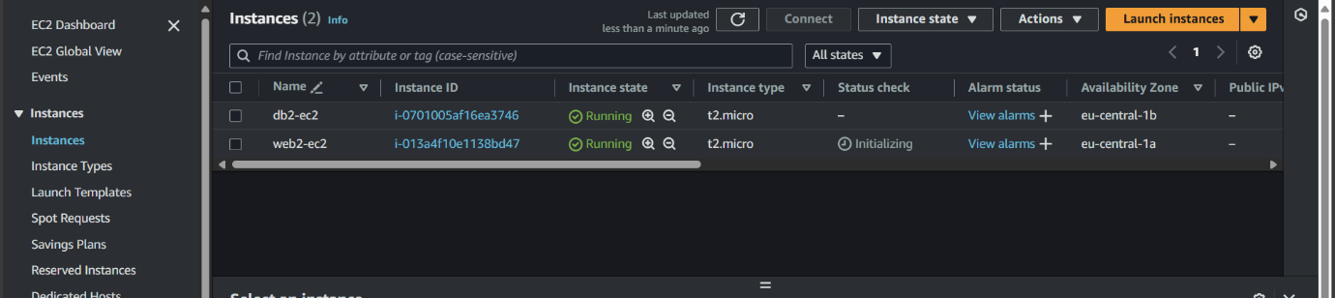

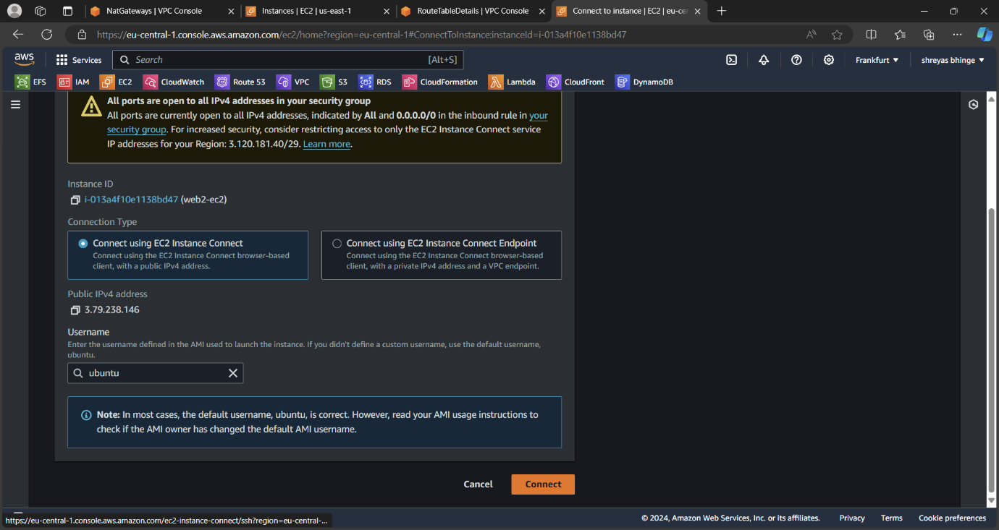

1. Create the peering connection in N.virginia

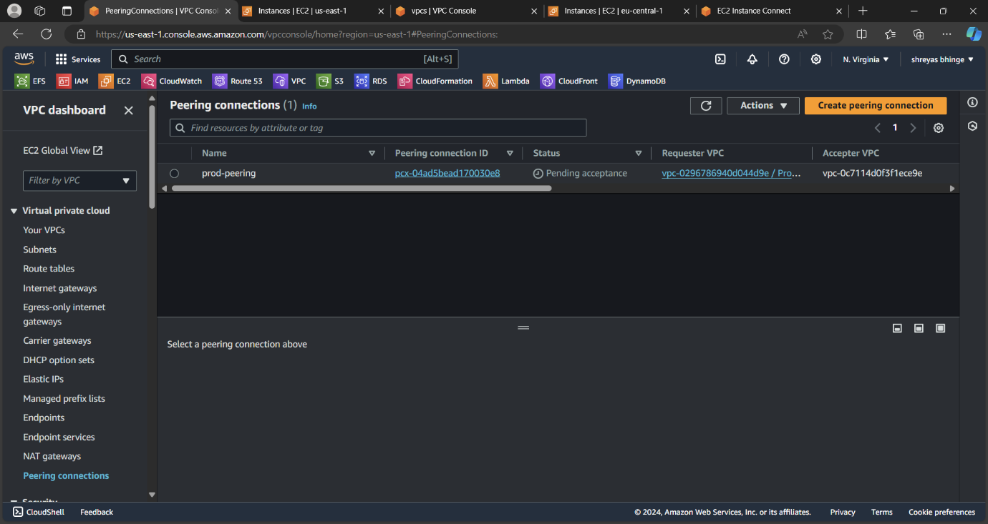

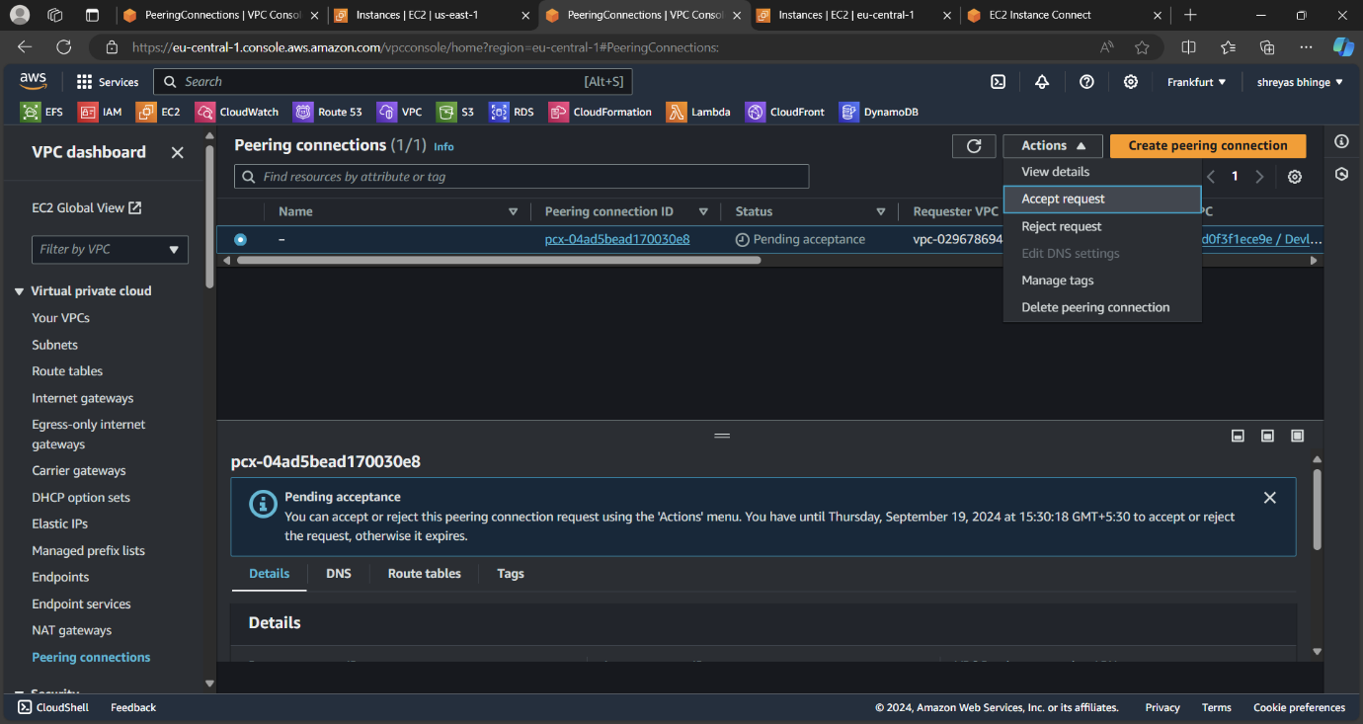

Accept the requeste in Frankfurt region

1. Created route table in Frankfurt and N.virginia and add peering connection

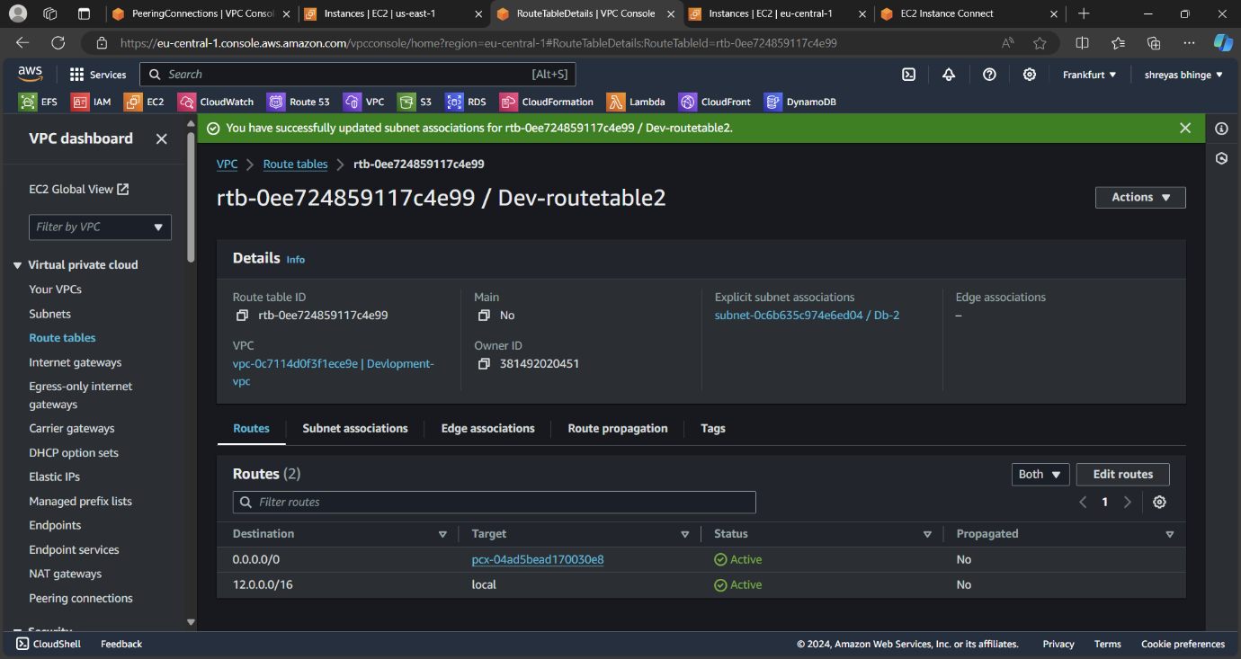

1. Add the following command and checked the connection

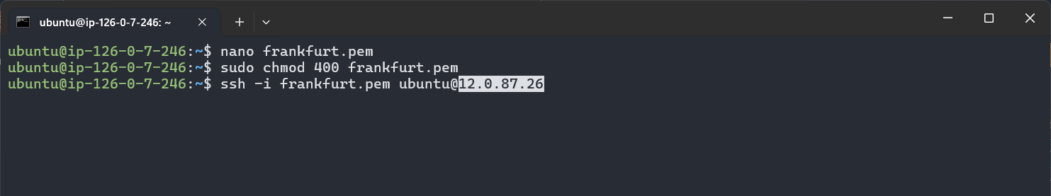

Connected

